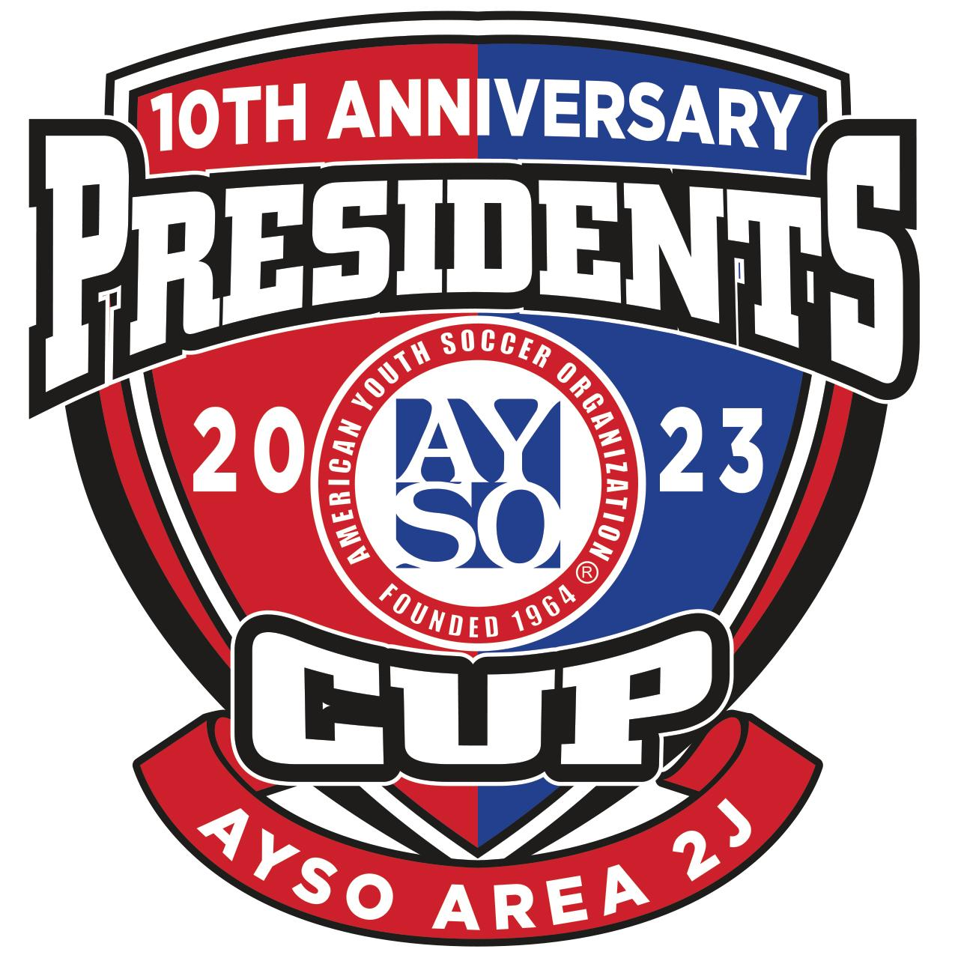
10th Annual
Area 2J President’s Cup Tournament
2023
Tournament Rules

- JURISDICTION

There will be no abuse of the tournament staff tolerated under any circumstances. Any persons who partake in any belittlement of tournament staff will immediately be removed from the tournament and unable to participate further in the tournament in any form. Serious issues will be reported to the proper Regional Commissioner and/or Area Director.
Unless otherwise noted, the current AYSO National Rules and Regulations and IFAB Laws of the Game will be used for this tournament. The following rules are intended specifically for this tournament ONLY!
The Tournament Committee (incl. Tournament Director, Assistant Director(s), Field Director, Referee Director, and other designated staff) will have jurisdiction over all games played. Disputes will be resolved by the end of the soccer day.

The Tournament Committee reserves the right to make adjustments to tournament rules and formatting leading up to and on the day of the tournament.
Referee judgment calls are NOT subject to dispute or protest!
- DATES / FEES
The President’s Cup 2023, will be played on the weekend of February 25th and 26th, 2023 for the 10U/12U/14U age divisions. The tournament will be held at the Morgan Hill Outdoor Sports Center in Morgan Hill, California.

Tournament fees are due 2/11/2023 for all teams.

Should your team not be accepted, the check will be returned or destroyed. The fee must be a single check issued from an associate AYSO Regional account.
- Fees are: 10U $600; 12U $660; 14U $700;
- No referee deposit is required.
AYSO Competitive Divisions are available in the 10U, 12U and 14U divisions.

Checks should be made out to:
Payee “American Youth Soccer Organization”
Comment “President’s Cup 2023, <Team Name>”
Mail checks to:
Tournament Registrar
1262 Ashcroft Lane
San Jose, CA 95118
pc_registrar@ayso2j.org

- ACCEPTANCE
The application process opens on December 22, 2022, and closes on January 27, 2023. Applications may be accepted after that date, but will only be accepted on a space-available basis or put on a waitlist. Applications will be accepted on a first-come basis, based on a completed application, completed on www.Gotsoccer.com.

https://www.gotsport.com/forms/app/?EventID=89530

Teams will be notified by email within 72 hours of the receipt of the applications of their status. (Accept / Waitlist / Reject)
Teams not accepted into the tournament will be offered the opportunity to be placed on a waiting list. If a team chooses not to be on a waiting list, the application and any entry fees will be returned or destroyed within 72 hours of notification.
The primary form of communication between the Tournament and applying teams will be email, PC@AYSO2J.org, the Tournament website, www.2jpresidentscup.com and the “GotSoccer” web application. Teams must designate a Team Contact on their application who has email and Internet access.
Tournament Questions can be sent to PC@AYSO2J.org.
The President’s Cup Tournament makes a determined attempt to include and accept all teams that apply. Being on the waitlist can mean that we are working to include your team in the excitement of tournament play. Please check regularly if your team is put on the waitlist for changes and updates.
- REFUNDS
Teams withdrawing before January 27th, 2023 will be issued a full refund. Teams withdrawing after January 27th, 2023 will be prorated to cover tournament expenses, unless a replacement team can be found.
If the tournament is canceled and cannot be rescheduled, a full refund will be issued.
- RAINOUT/CANCELLATION
If the tournament is canceled due to weather after partially completing and it cannot be rescheduled to be completed, refunds will be made to teams on a prorated basis, based on the number of actual games played to a 3-game minimum.
If the tournament cannot be held due to weather or other conditions beyond the control of the tournament hosts, then a full refund will be sent to all teams, less the cost of any pre-ordered items (items for sale by the tournament which are not included with the registration fee). Any pre-ordered items will be sent to the team.
For 2023, no rainout dates have been scheduled.

- PLAYERS/TEAMS
Players on participating teams must be properly registered to play in AYSO for Fall 2022 or Spring 2023. Coaches are responsible to ensure that all players meet eligibility requirements. The Presidents Cup event is open to only AYSO players/teams registered within the Sports Connect system.
GotSoccer tournament roster changes are allowed until February 18, 2023 for 10U/12U/14U.

Up to three (3) guest players will be accepted for this tournament. A “guest player” is a player not registered in the teams sponsored Region.

Division 14U will play 11-v-11, and there will be a roster limit of 18 players per team.
Division 12U will play 9-v-9, and there will be a roster limit of 15 players per team.
Division 10U will play 7-v-7, and there will be a roster limit of 12 players per team
All players must play at least 50% of each game, with quarter subs for 12U and 14U. Games that go into overtime do not have any playing time limitations.
Violation of these player rules exposes a team to protest and renders them subject to forfeiture of game, points deduction, and/or disqualification at the discretion of the Tournament Director.
- COACHES
Each team must have and is limited to two coaches – one Head Coach and one Assistant Coach. These coaches must be the ones listed on the Official Team Roster in Sports Connect (Formerly Blue Sombrero).

Each Coach must be a currently registered adult (18+) volunteer. All Coaches need to have completed Volunteer Background Check Risk Status: Green, Safe-Haven certification, CDC Concussion Awareness, Sudden Cardiac Arrest, Finger Printing, Safe Sport, an AYSO coach ID, and AYSO training at the age-appropriate level. Coach and Safe Haven Certifications are required to be uploaded to GotSoccer.

For instructions on how to get access to, and upload the Coach and Safe Haven Certifications, please go to www.2jpresidentscup.com and select the tab Forms/Docs.
Coaches are expected to set the example for their team in exhibiting proper AYSO behavior and Kids Zone behavior. Coaches are expected to remain in the technical area during games and only enter the field of play as requested by the referee.

In accordance with IFAB laws and AYSO policy, referees have the authority to 1) caution (yellow card) or send off (red card) coaches for their behavior; 2) stop/suspend a match and require a coach to address the behavior of their spectators, which could include having the spectator ejected from the facility; and 3) terminate a match because of outside interference. Teams may face additional penalties if a coach is sent off, if spectators are ejected, or if a match must be terminated.
Coaches are required to have all AYSO necessary documents available upon request of tournament staff.
- REFEREES
Each team in the tournament is asked to provide a crew of 3 referees. These referees will be assigned up to 3 games (or 9 game slots), based on their qualifications. The Tournament Referee Administrator will assign / re-assign all referee teams. Some games and referee slots will be open to self-select.

All referees must be an AYSO registered and trained volunteer, be Safe-Haven Certified, and have a minimum Regional level certification,
Only the diagonal system of control will be used to referee the games. A 4th Official is commonly used at most Presidents Cup games to support substitution policy and sideline control.
Center Referees for 14U games preferred to be at Advanced level or above.
Center Referees for 10U and 12U games preferred to be at Intermediate level or above.
All referees must be in full uniform as defined by AYSO and USSF, including the Referee Badge. Referees not in uniform will not be permitted to referee games. There will be no Referee Deposit for the 2023 President’s Cup tournament, but it is expected that all teams will provide a referee crew.
Referees are expected to check in at the Referee Station at least 30 minutes prior to their assigned game. Failure to appear on time may result in a replacement referee crew being assigned to the field. Once a replacement crew has been assigned, they will have priority and the original crew must report to the Referee station for an alternative assignment.
Coaches and players in the tournament will not be allowed to referee games in their own divisions.
Referees will be expected to uphold the tournament rules, AYSO Rules and Regulations, and IFAB laws. Any failure of the referee to uphold these rules may be cause for dismissal from the tournament.
The AYSO No Heading policy will be observed at the 12U and 10U Division level.

The AYSO Player Development Initiative for 10U will be used to cover no punting and no heading will be allowed. Additionally the use of a “build-out line” will be in effect for 10U division.
- FIELDS
For 2023 Morgan Hill Outdoor Sports Complex (MHOSC) will hold the 10U /12U/14U matches. The fields are a combination of turf and grass.
Trash cans will be provided at each field. Teams will be expected to clean up all trash in their area before leaving.
Please observe the Facility Use Rules while attending the tournament that are posted to the website for each field. Other services (such as portable restrooms, First Aid, etc) will be made available when possible.
- FORMAT
This is a pool-play tournament.
Each age division will be bracketed into playing pools.
Each team will play a minimum of 3 games. More games can be played and game time adjusted if the number of teams and available field time slots afford the extra games.
Pool Format and Playoff format are subject to change at the Tournament Director’s discretion based upon the available team / times / playing fields / and other factors as appropriate. The final format for each division will be provided to teams / coaches / parents via www.gotsoccer.com.
The President’s Cup philosophy is to provide more games than the minimum 3, if possible.
Player injury due to excessive playing time is considered in all division formats. Game durations will be adjusted to reduce the risk of injury due to exertion level.
- CHECK-IN
Pre-Tournament:
Required items for Online Team Check-in in GotSoccer:

- GotSoccer Tournament Roster, including all player Names and Date of Birth (matching Sports Connect)
- Coach and Safe Haven Certifications uploaded to GotSoccer.
- Full payment of Tournament Fee received.

We freeze the rosters in GotSoccer February 18th. After this date, no more changes can be made to your tournament roster.
Medical Waiver / Registration Forms:
By AYSO regulations, each coach or team representative must have these forms, with original ink signatures or e-signature, with them at all times during the event for verification by tournament officials upon request at anytime. Failure to produce these documents upon request will result in a forfeit of previous or future games, and/or a point deduction from pool play.

If documents cannot be produced before a team competes in its next scheduled game, disqualification of the team or of the individual player(s) from the tournament will occur.
.
Coach / Referee Conference Calls:
Approximately a week before the tournament weekend, a mandatory conference call will be held to allow coaches to review the tournament rules and ask questions.

A referee conference call will also be held, to provide tournament updates, and any modifications to all participating referees.

These dates will be posted on the tournament website when confirmed.
Day of Game Player Check-in:
All players and a team official must check-in at the field marshall 30 minutes before their first scheduled game of each day (only once per day).

- Players must be in full AYSO uniform and ready to play.
- Laminated Blue Sombrero Player/Coach Cards must be presented for all players included on the GotSoccer tournament roster.
- An equipment safety check will occur at this time.
All players, the Head Coach, and the Assistant Coach are required to have a Laminated Player/Coach ID Card, generated by Blue Sombrero. The Card must include the player’s/coach’s name, AYSO ID# and a picture. The Player/Coach ID Card must be signed by the Regional Commissioner.

For instructions on how to generate the Blue Sombrero Player/Coach ID Cards, please go to www.2jpresidentscup.com and select the tab Forms/Docs.

Referee Game Cards (also called Line-up Cards) will be generated by the tournament staff, with the players listed by first name-last name in jersey number order. This will be based upon rosters entered into the GotSoccer Website, finalized 1 week prior to the tournament division weekend. Coach do not generate line-up cards.
During Check-in, all players listed on the game card must have their Player ID Card present, even if there is an expectation that one (or more) might miss a scheduled game.

During the tournament, a late arriving player(s) must be escorted to the check-in station by a team official along with their Laminated Player ID Card and be cleared by the Tournament Staff before participating in any games. A player arriving after the game has started may only enter the game under the Center Referee’s discretion.
- FIELD MARSHALS
There will be a tournament Field Marshal assigned to each field/Division, and will report to the Tournament Director. Field Marshals will check-in teams prior to each game, and present the verified game cards to the match referees.
At the conclusion of the game, the match referees must return the completed game cards to the Field Marshall for scoring and tracking as needed. If possible, runners will attempt to collect game cards from the fields but if not referees should give the game cards to the Field Marshall immediately after the game concludes.
Field Marshals will be the first to respond to any incidents or injuries, and will be in contact with the rest of the tournament staff by radio or phone. Tournament participants are encouraged to report any concerns immediately to the Field Marshall, and also to respectfully follow any instructions given by the Field Marshall.
- GAMES
Pool play games will consist of two halves where the length is determined by age group as well as a five-minute half time.

Depending on total playing time over the tournament, 10U division game times may be lowered to prevent player injury due to exhaustion.
There will be a running clock during the match including substitutions. Time may be added by the Center Referee for injuries or time wasted in qualifying rounds. Games will expect to end on time, and may be shortened if they started late. Pool play games may end in a tie.
Each coach is required to have their team ready at the start of each half and to conduct substitutions in as expedient a manner as possible.
Consolation and Championship games will be played until there is a winner (see Medal Round rules below).

Division Pool Play / Medal Round
10U: 16 minute half / 16 minute half ***
12U: 20 minute half / 20 minute half *
14U: 25 minute half / 25 minute half *

*** No mid-half substitution for 10U divisions. Play will consist of 2 x 16 minute halves with no mid-half stoppage so please plan your line-ups accordingly and it is strongly encouraged that you rotate the players who get to play both halves from game to game.

* Standard AYSO substitutions mid-way through each half in addition to half-time.
Game Duration may be changed when the final schedule is posted on GotSoccer by the Tournament staff or Field Marshall. The President’s Cup tournament intends to provide as many games as possible, thus Game duration may change to accommodate more games and more overall playing time.
The “home” team will be the first team or top team listed on the game. The home team will change jerseys or don pinnies in the event of a color conflict with the visitor team. If any questions, the referee will determine whether this is necessary. Game balls will be provided by the tournament staff.
There will be no defined “warming up” on the field. Teams must warm up prior to taking the field. As soon as the previous game has ended, teams must clear the field and the teams for the next game must take their places.

BLOWOUT: 1 point deduction for every goal beyond a 5 goal differential until zero points is reached. Abuse of the blowout rule by deliberate own goals are not included in this.

FORFEITS: Teams must check in at the designated Tournament Table 30 minutes prior to the start of the game. There will be a five-minute grace period at the start of the game for a team to take the field before a forfeit is declared.

The minimum number of players per division is 10U – 5, 12U – 6, 14U – 7 players to continue a game. If a team cannot field the minimum number of players before or during play, the game will be abandoned and a forfeit will be declared.

The score for a forfeit match will be 1-0 for the remaining team (See STANDINGS for the points to be awarded). If that results in a favorable outcome for the forfeiting team, the Tournament Director or her designee may assign a different score in line with the overall philosophy of the tournament. If a “Double-Forfeit” occurs, no points will be awarded to either team.

- SUSPENDED GAMES:
The Tournament Committee may determine to end matches early if the field schedule is behind due to game delays, interference, or if weather conditions provide unsafe conditions; and may distribute awards according to games played and points. The Tournament Committee will determine the outcome of any single game which is terminated prematurely (due to inclement weather, participant injury, or interference by an outside party, etc.).

- ABANDONED GAMES:
If any pool play games cannot be played due to circumstances beyond the control of the tournament, the final standings of the pool will be determined by applying the Winning Percentage formula (Total Points Earned in all Game Played divided by Total Points Possible for the Number of Games Played) to each team in the pool. Note: This does not apply to games that were shortened due to a late start. Only the Tournament Director or her designee can declare a game to be abandoned or not played.

- SUBSTITUTIONS
All substitutions must be approved and recognized by the referee.
For 14U and below:
*For 20-minute or more halves, substitutions shall be allowed approximately mid-way through each half for all divisions and will be recorded on the game cards by the referee.
* For 15 minutes halves, substitutions shall occur only at the half. To increase playing time and not lose time for substitutions.
Substitutions may be made for injured players; however, they may not return until the beginning of the next quarter and will be considered as having played the current quarter (exception: an injured player who is not replaced, may return to play at any time with the referee’s permission).
Substitutions in overtime periods of medal-round matches will be at the beginning of each period only.

There is no maximum play time for Goalkeepers in any division.
- STANDINGS / SCORING
Standings for pool play games will be determined on a modified “ten-point system” as follows:
WIN = 6 points
TIE = 3 points
LOSS = 0 points
GOAL = 1 point per goal up to a maximum of 3 per game
SHUTOUT = 1 point for a shutout
FORFEIT = 8 points (scored as a 1-0 win) *See note on GAMES/FORFEITS.
RED CARD/
EJECTION = 2 point deduction for the team (includes 2 points for each player, substitute, or coach)
BLOWOUT = 1 point deduction for every goal beyond 5 a goal differential, (Own Goals are not included.)
Winners of ties in the standings will be determined in the following order:
- Head to Head competition
- Most number of wins
- Goal differential (highest differential advances; goals scored less goals allowed)
- Fewest goals allowed
- Least number of sportsmanship point deductions (1 point per misconduct, 1 point per spectator incident, 1 point for blowouts of more than 5 goal differential)
- Kicks from the Penalty Mark or Coin Toss if teams are not available.
There will be a continuous point deduction for each goal for teams that win by more than a 5-goal differential.
Standings will be updated hourly at the Tournament Scoreboard or on the GotSoccer website. The deadline to challenge the posted results will be at the conclusion of Pool Play.
- ADVANCEMENTS
The final advancement format will be published on the GotSoccer website and reviewed at the mandatory Coach meeting before the tournament as it is dependent on number of teams involved in the flight.
- TIES IN ELIMINATION PLAY
All elimination matches that end in a tie at the end of regulation play will immediately go to IFAB Kicks from the Penalty Mark. There will be no overtime periods or additional time.
- AWARDS
A team cup and medals will be awarded to the winning teams in each division. Medals will be provided for second and third-place teams in each division.
A lower division may be formed, and for that division, medals will be given for 1st place.
- CONDUCT
Coaches will be expected to set a positive example for the team, and will be held responsible for the actions of their team, including spectators. All spectators must remain behind the control line and between the 18-yard lines (penalty areas in small fields). Two coaches maximum per team, and they must remain in the marked coaching area (within ten yards either way from halfway line).
At the conclusion of each match, the referees will indicate on the reverse of the game cards any point deductions for poor sportsmanship. Point deductions will be used as tie-breakers should that become necessary.

Referees will be required to complete a game misconduct report for all misconducts during the game, as well as any incidents of interference by spectators.
Any coach or spectator ejected must immediately leave the vicinity of the playing field (out of sight and sound) and will be prohibited from attending the next scheduled game. Any player sent off (red carded) must immediately leave the vicinity of the game (under the supervision of his/her parent or Safe Haven-certified adult), and may not return to the field of play during the current game, including for the post-game handshake, and may not be substituted for, and is suspended from participation in the next game. An alternative for 14U and below, the player may stay on the sideline under the supervision of the coach. There will be penalty point deductions for all send-offs (see Standings / Scoring rules).
Any violent conduct red card or ejection may result in that player/coach/spectator being barred from the remainder of the tournament under the discretion of the Tournament Director.

If it is determined that an ineligible player has participated in a game, the team will forfeit all games in which that player participated illegally. Furthermore, if it is determined that the coach knowingly played a player illegally, that coach will be barred from further participation in the tournament.

It is mandatory to play a scheduled game. If it is determined that a coach willfully fails to have his/her team participate in a scheduled game, the coach will be dismissed from the tournament and the incident will be reported to the respective Regional Commissioner.
All conduct problems will be reported to the respective Regional Commissioner.
All serious incidents will be reported to the respective Regional Commissioner as well as Area, Section, and AYSO National Office parties.
- MEDICAL/FIRST AID
There will be a First Aid station near/at the main Field Marshal tent where participants may receive ice, etc. for minor injuries.
There will be a roving first aid response staff member to respond to injuries on the field. Field Marshals will communicate via radio/phone to call the first aid staffer to the field where first aid is requested.
If an injury is serious, the first aid staff or Safety Director will call 911 for emergency response. Directions to the nearest hospital/urgent care center will be available at the First Aid station.
- UNIFORMS/SAFETY
All players must wear the approved AYSO uniform only according to the National Rules & Regulations, and all players on the same team must wear matching uniforms (goalkeepers may have a different jersey while in that position, the AYSO logo is recommended but not required.)
Each player’s uniform must be marked with a permanently-affixed unique number that matches the uniform number on the Game Card, and may not exchange numbered jerseys with any other player during the game including the goalkeeper. No other markings (such as player name or team name) may be allowed in accordance with AYSO National rules.
Garments may be worn under the uniform (i.e. long sleeves, etc.) during inclement weather, however, the match referee will be the judge of what should be allowed or not.
Not allowed: Jewelry, hard metal, or plastic clips on clothing or hair. No player will be allowed to participate with any type of cast or splint. Removal of any type of cast or splint at the field or the surrounding area in order to participate shall disqualify that team member from participation.
AYSO will not prohibit the use of knee braces by players in AYSO events and programs; providing that the brace is adequately covered and padded in the judgment of the referee, so as to eliminate the possibility of its causing injury to the other players on the field.
- PROTESTS
Protests will be considered only for the following reasons:
* An ineligible player has played.
* One or more registered player(s), present and in uniform, have not played the required one 50% of the game (except for illness or injury as recorded by the game referee).
All protests must be presented in writing/email/text to the Field Marshal / Tournament Director within 30 minutes of the completion of the game.
All protests will be heard by a Protest Committee of at least three persons selected by the Tournament Director.
In all cases, the members of the Protest Committee will be unrelated to either team involved in the protest.
ALL PROTEST DECISIONS ARE FINAL!
Referee judgment calls are FINAL and are not grounds for, nor subject to protest or dispute!
- RULES INTERPRETATION
The Tournament Director retains the right to interpret and apply the tournament rules to the optimum benefit of all tournament participants.

